**Dallas Restaurant Analysis**

Mark Lee

May 2021

# Introduction

## Background

The city of Dallas has a robust restaurant scene, and one that has a [quickly growing Asian Cuisine scene](https://dallas.eater.com/2021/4/21/22394513/mike-chen-strictly-dumpling-dallas-asian-restaurant-dining-scene-spotlighty). The Dallas dining scene has been described as a “[worthy culinary destination that’s as diverse as it is accessible](https://www.heremagazine.com/articles/dallas-restaurant-scene/)” by Annie Werner for Here Magazine.

## Problem

Anyone looking to open a restaurant in Dallas, especially that serves Asian Cuisine, needs to understand the current lay of the land when determining the ideal location for a new establishment. This project aims to identify the best-suited locations for further inquiry.

## Interest

Our client has asked us to by examining which have the lowest restaurant density, and focus our search around the center of the city. Top priorities are locations with limited competition and locations with robust foot traffic.

# Data Acquisition and Cleaning

## Data Sources

* FourSquare.com’s API will be used to identify venues that we would consider competitors.
* WalkScore.com’s API will be used to evaluate the expected amount of foot traffic in the area.
* David Blackman has a repository of GeoJson files on GitHub to provide context for which Dallas Neighborhood each location is in

## Data Cleaning

We began by identifying the city center of Dallas, and restricting our search to a 10 km x 10 km circle around this point. From there, we created a geometric grid of locations divided into circles with a radius of 250 m.

We gathered a list of all food venues in each location from the FourSquare API. We determined that the following types of venues would not be considered competition and so excluded them from our search: Bagel Shops, Bakeries, Breakfast Spots, Bubble Tea Shops, Cafeterias, Coffee Shops, Dessert Shops, Donut Shops, Food Stands, Juice Bars, Pet Cafes, Snack Places, Tea Rooms, and Truck Stops.

We also noted whether the food venue served Asian Cuisine, served Thai food specifically, or served food of another type.

We also used the latitude and longitude from each location to pull the WalkScore.com score for each location.

# Methodology

## Exploratory Data Analysis

We started by calculating the total number of restaurants in each area, as well as the average distance to the nearest Asian Restaurant, and the average distance to the nearest Thai Food Restaurant.

Table 1: Sample Table of Total Restaurant Count for Each Location

| **Latitude** | **Longitude** | **Distance from Center** | **Neighborhood** | **Total Restaurants**  **in Area** |
| --- | --- | --- | --- | --- |
| 32.7370 | -96.8134 | 4963.814213 | South Dallas | 1 |
| 32.7369 | -96.8081 | 4862.041911 | South Dallas | 0 |
| 32.7368 | -96.8028 | 4810.348381 | South Dallas | 0 |
| 32.7368 | -96.7974 | 4810.348381 | South Dallas | 4 |
| 32.7367 | -96.7921 | 4862.041911 | South Dallas | 0 |

For each location, the average distance to the nearest Asian Restaurant was 1.41 km and the average distance to the nearest Thai Food Restaurant was 1.64 km.

In total, we identified 208 locations out of the initial 365 that contained 0 or 1 restaurant.

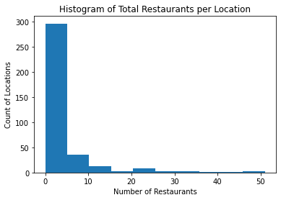

## Scoring the Suitability of the Remaining Locations

We chose 3 criteria with which to evaluate each of the remaining 208 locations.

* The distance to the nearest Asian Restaurant
* The distance to the Dallas City Center
* The WalkScore.com rating

These combined scores created a balanced overview of the required criteria as most locations near the city center would score well on foot traffic and poorly on proximity to other Asian Restaurants, and those farther from the city center would show relatively opposite results.

The higher the total score, the better the location’s overall ranking.

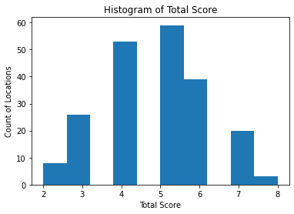

# Results & Discussion

After evaluating the scores, three locations shared the highest score (8 out of 12), and twenty locations had a score of 7 out of 12.

|  |  |
| --- | --- |
| **Total Score** | **Number of Locations** |
| 0 | 0 |
| 1 | 0 |
| 2 | 8 |
| 3 | 26 |
| 4 | 53 |
| 5 | 59 |
| 6 | 39 |
| 7 | 20 |
| 8 | 3 |

The below map shows that the most promising locations are near the city center, in small pockets of space where there are not currently many other restaurants.

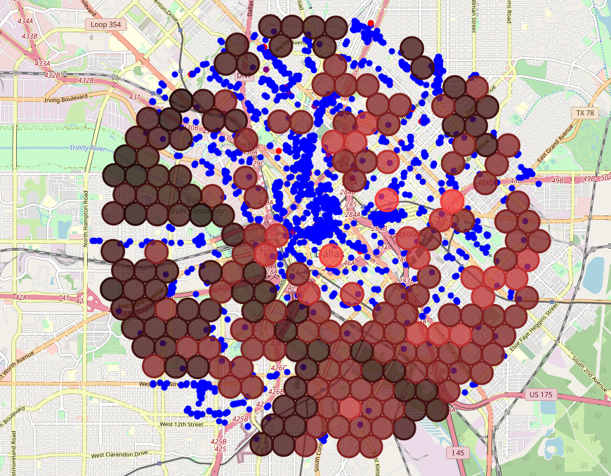

The combination of scores for both Walkability and Distance from City Center weighed the resulting total score appropriately to put more emphasis on the overall traffic in a location. The score for Distance from Nearest Asian Restaurant was slightly less powerful, to appropriately rank the residential areas without much competition slightly lower than the downtown areas with competition that was slightly higher but still within an acceptable range.

# Conclusion

Our analysis shows that Dallas is a large, complex city with a significant number of restaurants. However, there are certainly areas with a very high density of restaurants, and other areas with a much lower density of restaurants. We determined that there were a large number of areas within a 10 km radius of the city center that actually contained 1 or 0 restaurants.  
  
We then narrowed our search to those areas with limited competition. We graded each location on their distance from city center, their distance from the nearest existing Asian Cuisine Restaurant, and their walkability score from WalkScore.com.

This project aimed to analyze the city of Dallas and identify locations of interest for a potential new Thai Food restaurant. After narrowing the search to locations with limited competition, we can a list of possibilities in order of suitability based on the specific factors of walkability and distance from the city center. Other factors will need to be considered when stakeholders are determining which area from the list best suits their needs.